**SYNOPSIS**

**Disease Pre-analysis System**

**Name:** Akshansh Mahajan, Anmol Verma, Jaspreet Singh.

**Roll Number:** 2110993756(G-2), 2110993762(G-2), 2110993802(G-2).

**Submitted to** – Ashutosh Hiskiel Sir.

**Problem Statement**

To pre analyze diseases using Machine Learning in Python.

**Introduction**

This analysis system will help hospitals to redirect the patients to the required doctor accordingly and thus saving the time consumed in analyzing and questioning done by doctors to analyze the problem. This will help to greatly reduce the crowdedness and pressure on doctors in hospitals.

We will be able to detect 41 diseases based on symptoms, some of which are

Heart attack

Psoriasis

Jaundice

GERD

Tuberculosis

Urinary tract infection

A questionnaire will have to be answered by the user which will consist yes, no based questions like

If the user is having symptoms like:

Itching, skin rash, nodal skin eruptions, continuous sneezing, shivering, chills, joint pain, stomach ache, acidity. Based on the answers a prognosis will be generated.

**TECHNOLOGY**

Disease Pre-analysis System will be built using:-

* Python
* Joblib
* Gradio

**Flowchart**

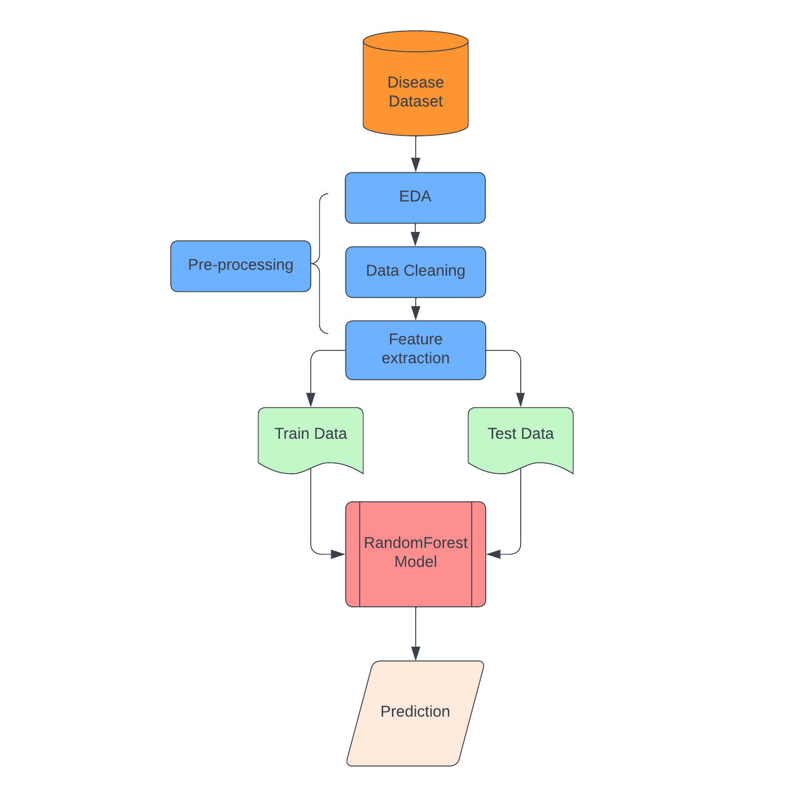

**References**

* [Disease Prediction Using Machine Learning | Kaggle](https://www.kaggle.com/datasets/kaushil268/disease-prediction-using-machine-learning).